EPSA -Newsletter October, 2022
Namaste dear EPSA Friends,
Now that we were overcoming the Covid times, and getting back to normal life, Nepal has been affected by an epidemic of dengue, and some of our girls also suffered it. Despite that, we are working hard to fulfill the orders on time, and we are very thankful to everyone to keep trusting and ordering from us.

We want to share with all of you what this last year has brought us and all the activities we have done and achieved.
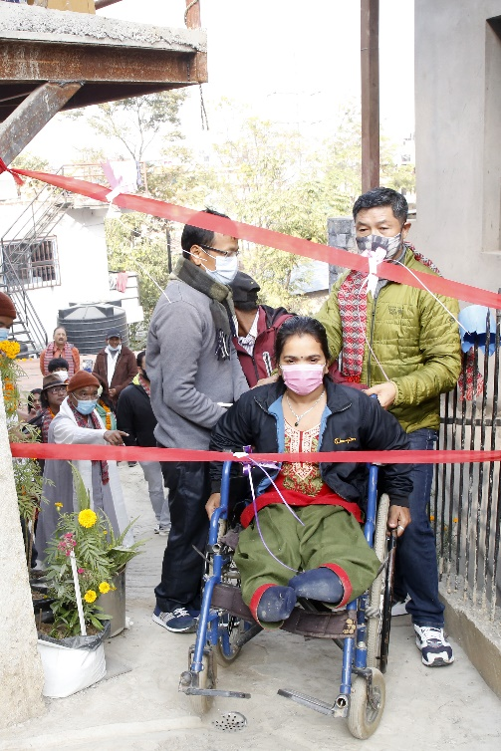

Later on, Mr. Sushil Thapa from Diagnotech Support PVT. LTD. helped to build a wheelchair ramp. Here which is beneficial for all those who wants to visit us and are wheelchair users.

As we shared in the past newsletter, Supreme Master from Bodhi SattavVihar organization provided us help to reconstruct and renew a building for a better safety for our girls and to conduct the work. On November 2021, the same organization and some other guests, including the mayor of Tarakeshwar, inaugurated this renewed building.
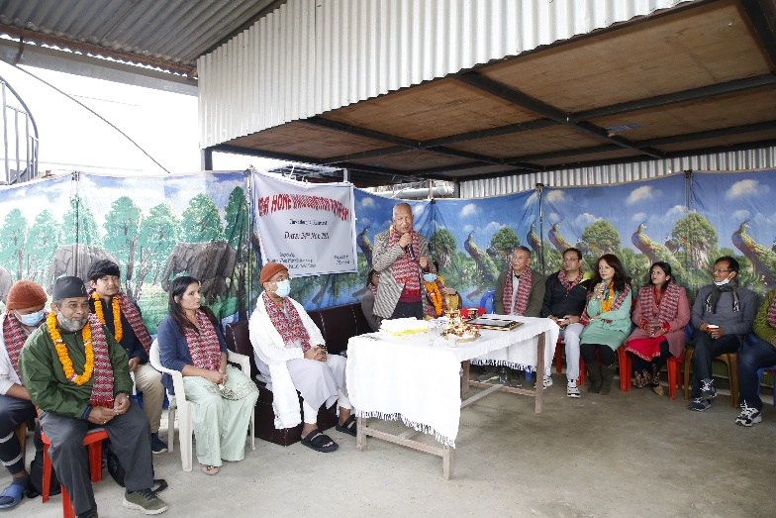
You can see below pictures of that beautiful day.
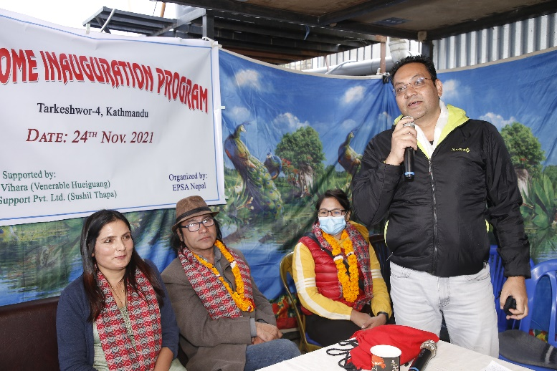

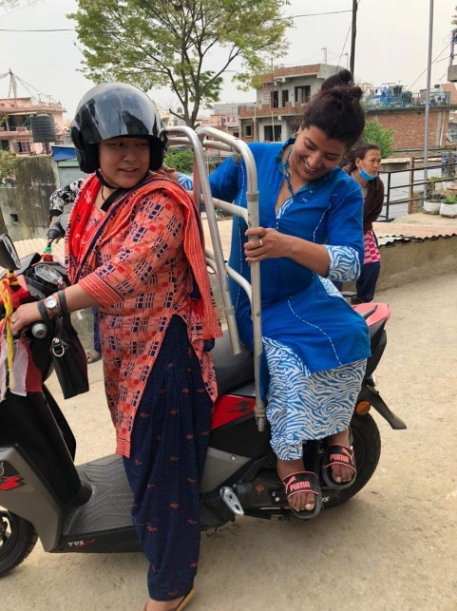
At the end of 2021, on December, Urgen Wangchuck and Janet Farr Parks, raised some money to purchase a mobility Scooter & Birgit Ninas friend from Germany raised Euro 2100 to buy a TVS Antrock for us to buy a new scooter. We are very grateful to you everyone. This is very helpful for us to move around, visit suppliers, clients, medical visits…Also We are very thankful to them and all the people who participate in the fundraising.

This April, 2022 Mr. Rupa Karki from USA, helped us with a collection of kitchen appliances. It use very useful for residential girls.
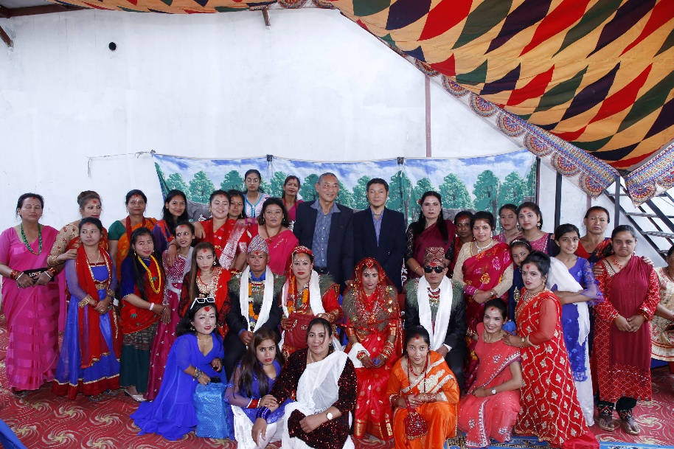
On April as well, two of our girls got married. We organized the ceremony and party in our home and we had a very good time and enjoyed. We wish them a happy and successful marriage life!

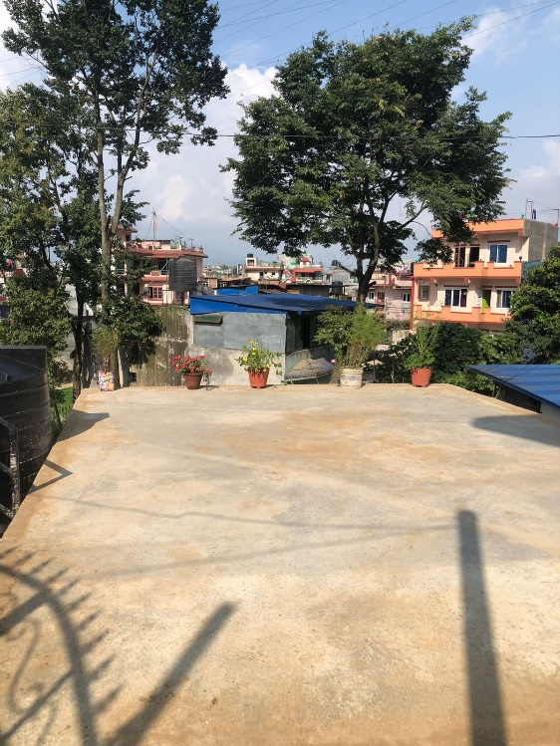

Throughout all the year Annelies and Katharina, from Switzerland, have been helping us a lot, sending money for medicine, food, health hygiene… even for the construction of a French bar in the rooftop of the new reconstructed house. Now rooftop has been using as a multifunctional. Thank u so much Dear Anniles, Katharina & the friends.

Last August we established a community store. A small shop located in the old EPSA Nepal where we sell vegetables, cold drinks, water… This new project was only possible with the help of Heart2Heart Canada – Nepal, with Ms Janet Farr Praks and her friend. From here we sent our gratitude to them.
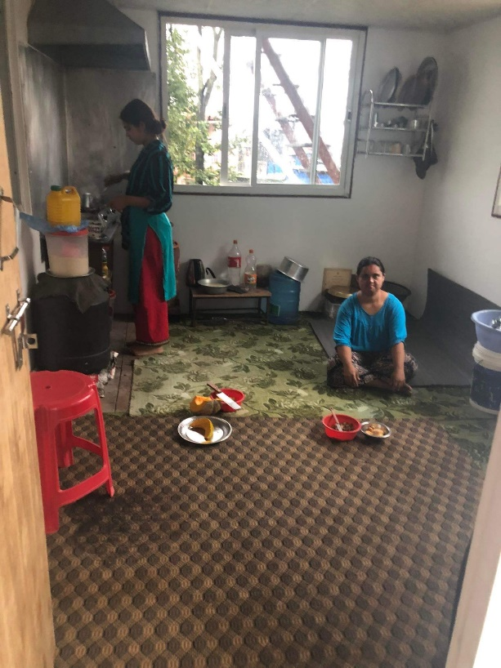
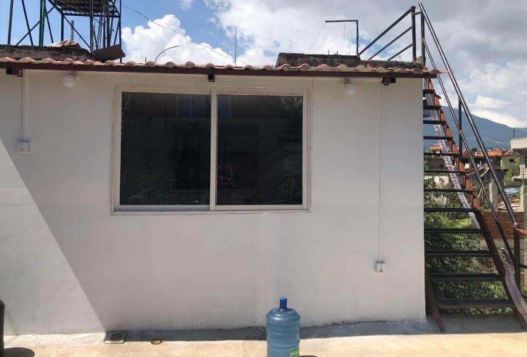
Also in August 2022, Audrey Jacob Foundation Switzerland (Astrid Beseller), helped here to build a small kitchen after built rooftop for 4 severed disabled girls.

September and October are months of celebrations, including Laxmi Puja, Dashain festival and Tihar. We also celebrate these festivals and some of us even travel to our villages to visit the relatives there.
Also, Annelise and Katharina,(SURYA VERIEEN) from Switzerland, are going to support and sponsor 5 newly girls in their educations. Thank you so much, again!
Upcoming project: Universal weaving facilities 2023, jointly with KARNOR, EPSA and FOUND. The construction work for this project is going to start from November, and once it will be completed, our plan is to be able to employee more women. We will need all of your support and help in the coming future for this construction & TRAINING as well to implement this project.
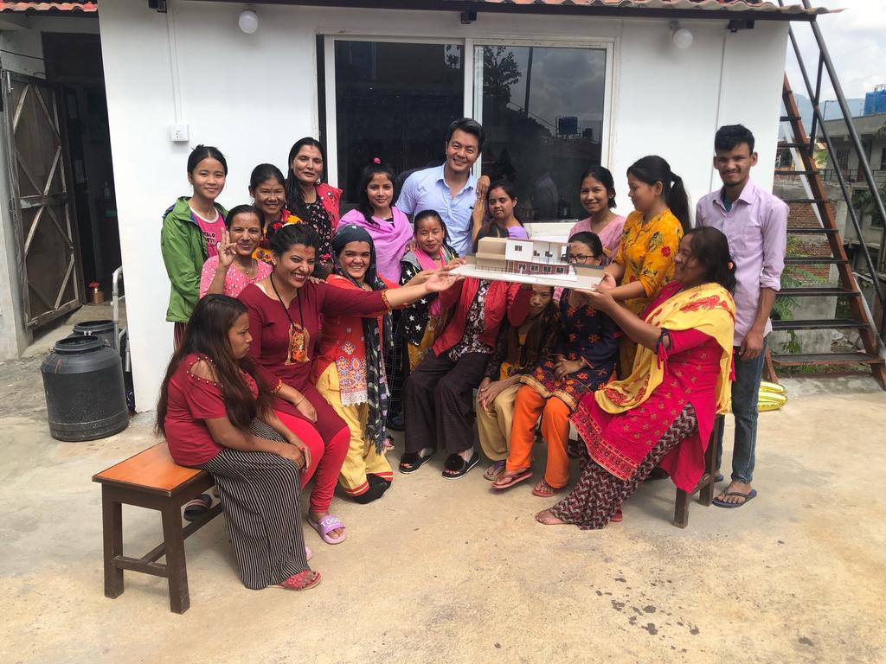

Thank you all for your support and looking forward to welcome you in EPSA soon.

